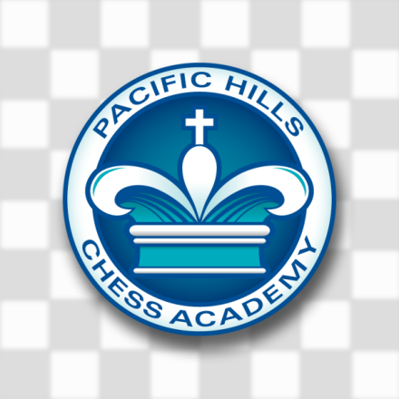

##### Everyone welcome: Beginners to Advanced!!

## Benchley-Weinberger

#### ***Spring 2024 Wednesday Chess Classes***

***Grades 1-5 In the library!!***

Chess is a great workout for the mind utilizing continuous problem-solving with changing conditions. Students learn to think ahead, evaluate multiple alternatives and anticipate consequences. They improve spatial reasoning, visual memory and attention span while learning good judgment, reasoning power and self-confidence. Studies show that chess improves cognitive thinking which in turn improves student achievement.

Former San Diego Chess Club President, Ron Rezendes and staff have over 20 years experience teaching chess in schools throughout San Diego. The program, dubbed “The Evans Method” by the United States Chess Federation, includes instruction, formal, and casual play. Students receive incentives at the end of each class to reward positive participation and trophies or medals at the end of each session. The program, once featured on The Tonight Show, has produced national champions at every scholastic level.

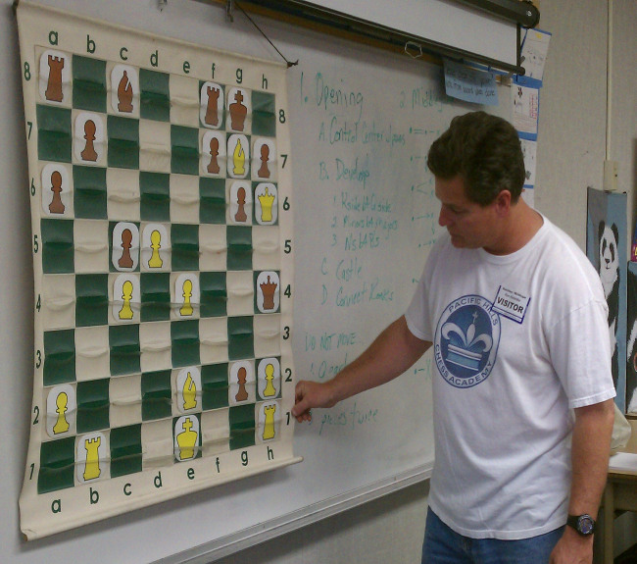

**Wednesdays 11:50 – 12:50 PM**

**Mar 6. 13, 20 Apr 10, 17, 24 May 1, 8, 15, 22, 29**

Benchley-Weinberger: Wednesdays 11:50-12:50PM Register for the Spring Session (11 classes), complete the form, bring a check/MO for $165.00 payable to: Ron Rezendes, to the first class, or sign up online on our website: http://www.pacifichillschessacademy.com/sign-up-online/

# Child’s Name Grade Home Phone Work Phone

*Parent’s Name Street Address Email Zip Code*

*619-630-7667 ◊ www.PacificHillsChessAcademy.com*